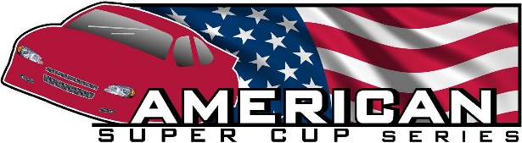
American Super Cup Series Motor Sealing Procedures
Our sealing procedures are unique and FREE to all paid members. Any GX390 motor can be purchased complete or worked on by anyone. All motors must meet ASCS rules. We seal all motors in front of 3 series members or series officials. All measurements and documentation are recorded and it takes approximately 2 hours. Certification paperwork can be provided if requested. ASCS keeps a file of all sealing records and takes them to each race
To get a motor sealed.
1. Motor must be drained of all oil
2. Motor must have been degreased, power washed, scrubbed and cleaned
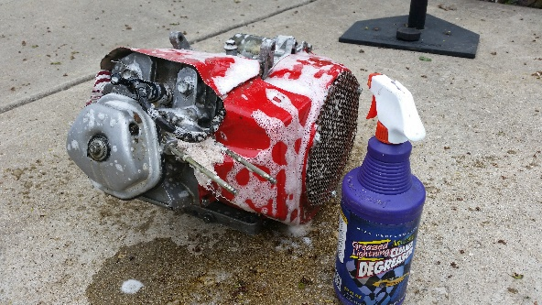 * If the above requirements are not met sealing could be refused.
The following will happen at the sealing.
The motor must be fully assembled. The series is not responsible for example – installation of the piston, cam, springs etc.
The head will be removed, inspected internally, externally and measured.
The side cover will be removed, inspected internally, externally and measured.
The fly wheel cover and fly wheel will be removed and inspected.
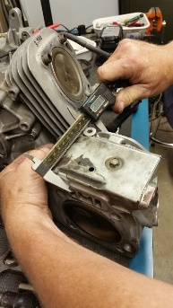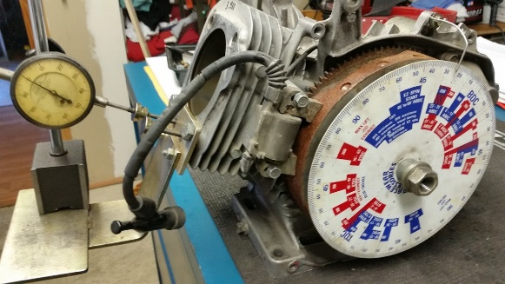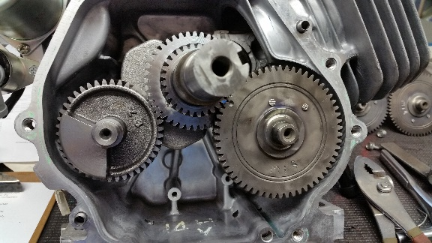
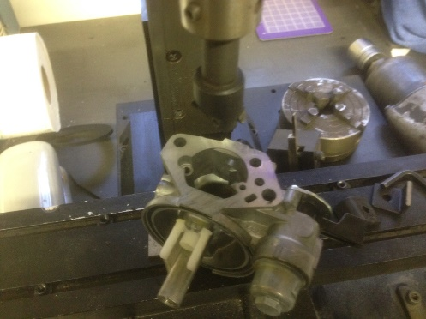
The carburetor should have been removed and drained of all gas for measurement and inspection.
*- See next pages for standard inspection report information
Upon inspection and approval either your team sealer or Kinetic Motorsports can assemble the motor and install seals. If fan, side cover seal or head gasket is in need of replacement this is the owner’s responsibility. Any other work or issues that appear are the owner’s responsibility. Illegal/bad parts could be confiscated and destroyed.
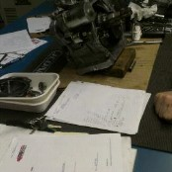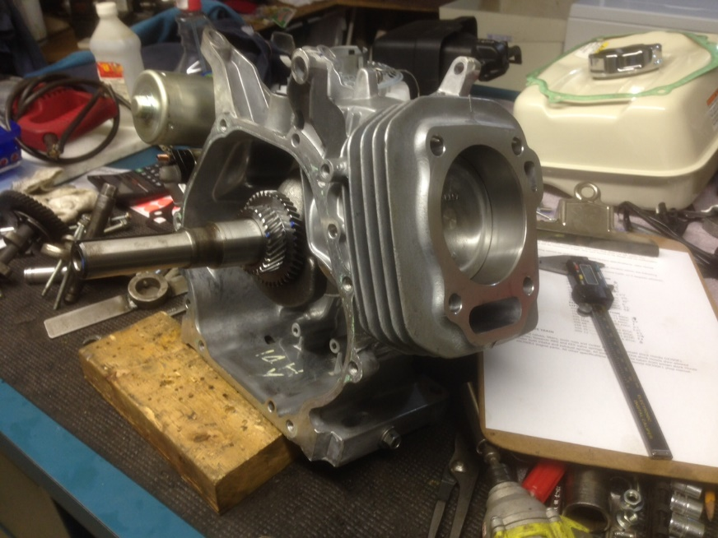
Finally seals are put onto motor. Unless a fully paid protest is presented or series request is presented the motor will remain sealed. Any tampering with a seal that is discovered in the inspection process is the responsibility of the owner and will require another inspection of the effected seal. This could be a chargeable offence. Members are entitled to one sealing per season. Additional sealing’s are charged accordingly.
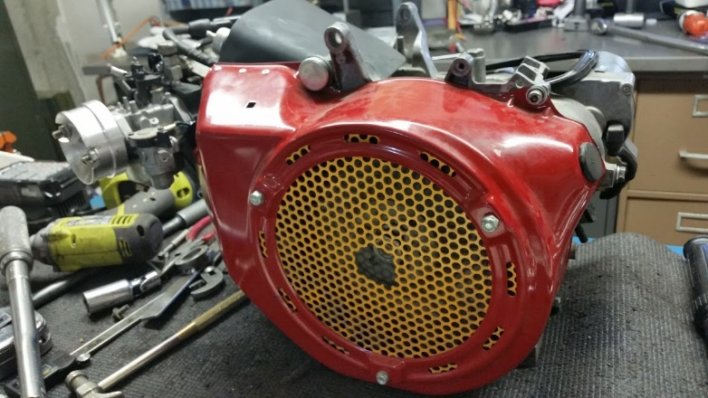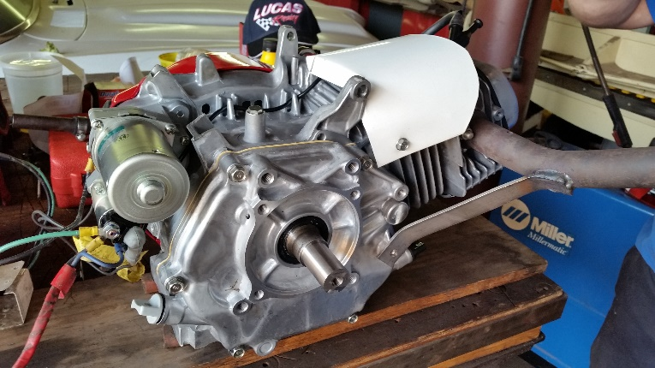
To race with the ASCS you need to have your motor sealed prior to competition.
ASCS is proud to offer free sealing and feels that this method of sealing has led to the most competitive Super Cup Racing in the country. While many other series send motors to “approved sealers” at a large cost to each team we are able to keep cost low and competition at a high level. Approved sealers have occasionally exceeded limits for a price. This has given some unfair advantages to some on the track. ASCS procedures have kept everyone on a level playing field for years.

To make appointment to get motor sealed, contact Mick Ellis
(312) -350-5566 - Cell
mellis31@att.net - Email

