You are Cordially Invited to the 2019 Championship Banquet

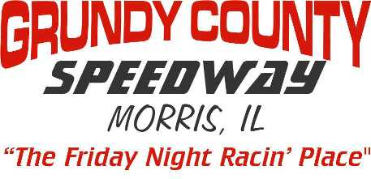
Saturday Night November 9th, 2019 From 6PM-11PM
6PM - Doors Open & Cocktails 7PM - Dinner Served
8:15PM - Awards, Trophies & Dancing

Awards Given To Top 10 In All 4 Divisions
Plus Top Rookies & Special Awards
All Drivers, Crew Members, Employees & Fans Are Welcome

Join us at: Chapin’s East - 502 Twin Rail Dr. Minooka IL.

Please Mail In Form No Later than Friday October 25th Tickets Are $30 Each
Pre-Paid Tickets Only NO TICKETS AVAILABLE AT DOOR - Dress Casual, No T-Shirts
___________________________________________________________________
2019 Banquet Reservation Form – Tables Set For 8
I Need________Tickets @ $30 each TOTAL Amount $ ____________ Enclosed

Tickets in Name of ____________________Phone Number__________________
Contact E-mail Address______________________________________________
Driver Affiliated With_______________________If No Driver - Check Here ( )

PLEASE PRINT NAMES Getting More Then 8, Print Extra Names On Back
1_________________________________2________________________________
3______________________4_____________________5_____________________
6______________________7_____________________8_____________________

Make Checks Payable to: GRUNDY COUNTY SPEEDWAY
Any Questions? E-mail us at – Info@GrundyCountySpeedwayOnline.com

Mail Payment To: Chuck Yuris
16633 W. Seneca Dr.
Lockport, IL. 60441

