You are Cordially Invited to the 2021 Championship Banquet

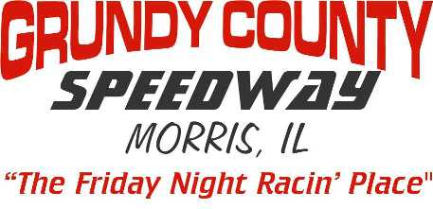
Saturday Night November 6th, 2021 From 6PM-11PM
6PM - Doors Open & Cocktails 7PM - Dinner Served
8:15PM - Awards, Trophies & Dancing

Awards Given To Top 10 In All 5 Divisions,
Plus Top Rookies & Special Awards
All Drivers, Crew Members, Employees & Fans Are Welcome
Join us at: Gardner American Legion: 426 Industry Ave, Gardner, IL.

Please Mail In Form No Later than Tuesday October 26th Tickets Are $30 Each
Pre-Paid Tickets Only NO TICKETS AVAILABLE AT DOOR - Dress Casual, No T-Shirts
___________________________________________________________________
2021 Banquet Reservation Form – Tables Set For 8
I Need________Tickets @ $30 each TOTAL Amount $ ____________ Enclosed

Tickets in Name of ____________________Phone Number___________________
Contact E-mail Address_______________________________________________
Driver Affiliated With______________________If No Driver - Check Here ( )

PLEASE PRINT Guest Names – More Then 8, Print Extra Names On Back
1_________________________________2________________________________
3______________________4_____________________5_____________________
6______________________7_____________________8_____________________

Make Checks Payable to: GRUNDY COUNTY SPEEDWAY
Any Questions? E-mail us at – Info@GrundyCountySpeedwayOnline.com

Mail Payment To: Steve Bechtel
2005 W. 139th St. #111
Blue Island, IL. 60406

