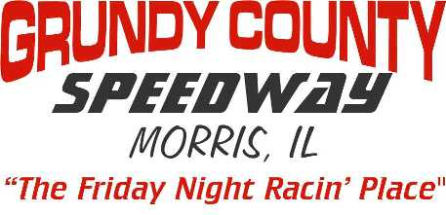
2021 Pit Pad Rental Agreement
Make Check Payable to: Grundy County Speedway

CAR #._____ DIVISION: LM $100 MA $100 SS $100 (Open spots filled in by waiting list)

Driver Name_________________________________________________________________________
Phone #___________________________________Home Cell

E-MAIL_______________________________________________________

( ) Area 1 North to South – (Main Row) Pads 1- 39

( ) Area 2 East to West – (Tire / Gas Sales Row) Pads 56 – 41 (46 & 47 Gas/Tires)

( ) Area 3 (Concession Row) Pads 57- 61

PIT PAD AGREEMENT
I intend to participate in ALL Grundy County Speedway promoted events. I understand this pad may not be shared, leased or given to any other competitor during the season on nights I’m not there. If I am not racing it may be used by others and if not occupied by 6:30PM and notice has not been given, the pad can be reassigned. Only park the car (division) you registered the pad with. If I’m not racing, I will not park my personal vehicle on my pad. During non Grundy County Speedway promoted events you may be moved to a different spot. Pads need to be paid in full by May 8th, 2021. If arrangements for payment are not made, fee will be deducted from earnings. After that date, any pads not paid for will be considered open and we will fill these spots based off of our waiting list. All agreements with former promoters and management are null and void effective January 1, 2013.

Sign Here - _________________________________________
( ) Same Pad I Had Last Year
( ) First Available - Mark Area Requested Above

Office Use - Paid Cash( ) Paid Check( ) Check #__________ Amount $___________

Pad # Assigned________________

