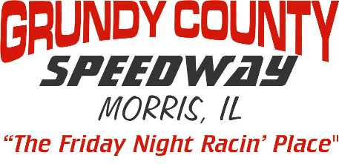
2026 Pit Pad Rental Agreement
Make Check Payable to: Grundy County Speedway

CAR # _____ DIVISION: SLM/Big 8 LM $100 Sportsman $150 Street Stock $150 Pure Stock $150
(Open spots filled in by waiting list)

Driver Name__________________________________________________

Phone #_________________________________________________

E-MAIL_______________________________________________________

PIT PAD AGREEMENT
I understand this pad may not be shared, leased or given to any other competitor during the season on nights I’m not there. If I am not racing the pad can be reassigned by the track. Only park the car (division) you registered the pad with. During non Grundy County Speedway promoted events or non point nights you may be moved to a different spot. Pure Stocks & Street Stocks may be moved off pads as needed in extreme situations. Pads need to be paid in full by May 15th, 2026. If arrangements for payment are not made, fee will be deducted from earnings. After that date, any pads not paid for will be considered open and we will fill these spots based off of our waiting list. All agreements with former promoters and management are null and void effective January 1, 2013.

Sign Here - _________________________________________
( ) Same Pad I Had Last Year
( ) First Available

Office Use - Paid Cash( ) Paid Check( ) Check #__________ Amount $___________

Pad # Assigned________________

